Milestone 2. Core functionalities Development
Activity 2.1 Develop the core functionalities:
Generate Structured Comic Panel Outline
Function: generate_outline()
File: gemini_flash.py
- This function uses the Gemini Flash AI model to generate a structured 5-panel comic outline based on the user's story prompt.
- Each panel contains a panel number, title, scene description, and an image generation prompt.
- The output is a list of dictionaries, one for each comic panel.
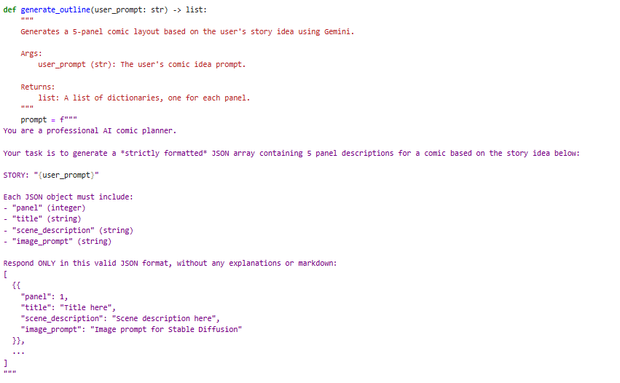
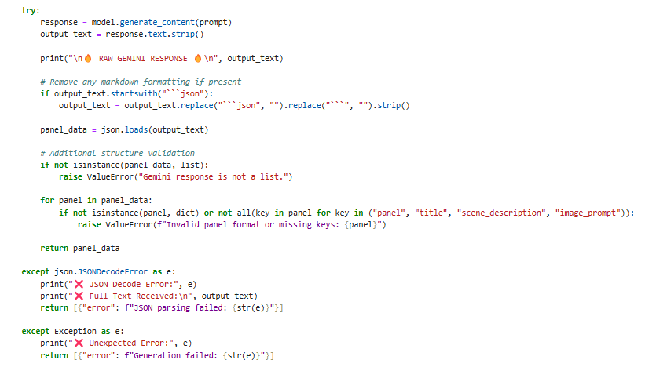
Generate Comic Story Narration and Dialogue
Function: generate_story()
File: gemini_pro.py
- This function uses the Gemini Pro AI model to expand the panel outlines into a full comic-style story.
- It creates engaging narration and character dialogues for each panel.
- The output is a single formatted text containing all the panels' stories.
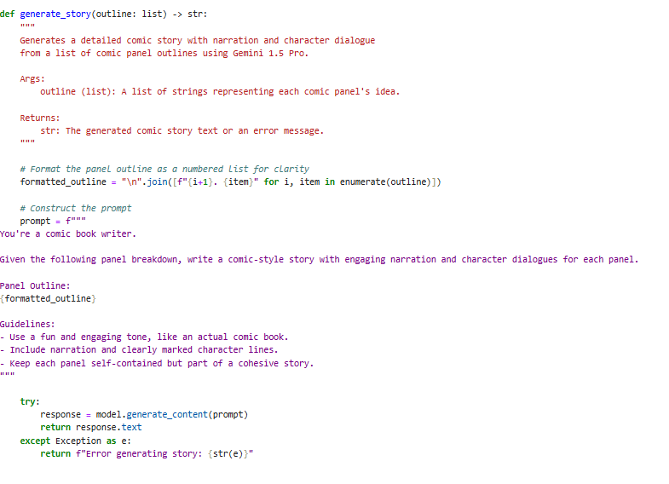
Generate Comic Illustrations from Prompts
Function: generate_image()
File: image_generator.py
- This function uses the Stable Diffusion model to create a comic-style image based on the provided image prompt.
- It sanitizes the prompt for safe filenames and saves the generated image to the static/panels directory.
- Returns the file path to the saved image.
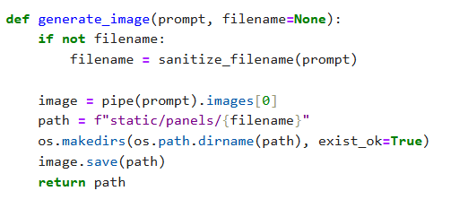
Organize Comic Panels into Layout Structure
Functions: build_comic_layout()
File: layout_builder.py
- This function organizes the generated images and full comic story into a structured layout.
- It matches each image with its corresponding panel story.
- The output is a list of dictionaries containing the panel number, image path, and text.
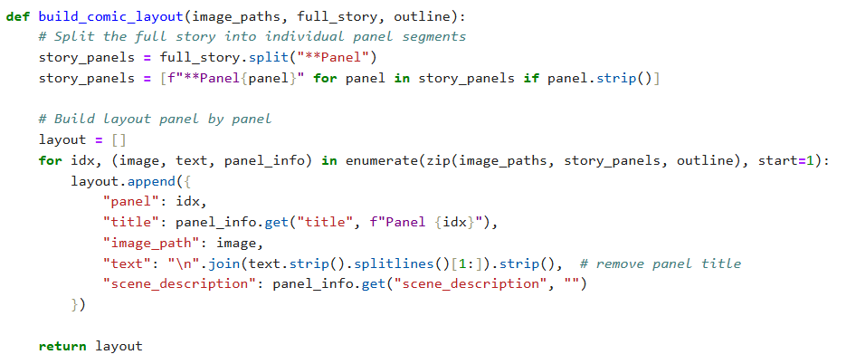
Export Comic Panel and Story into PDF
Function: save_pdf()
File: exporters.py
- This function compiles the full comic into a multi-page PDF file using the FPDF library.
- Each panel’s image and narration are placed neatly on separate pages.
- The final PDF file is saved into the static/exports folder, and the path is returned.
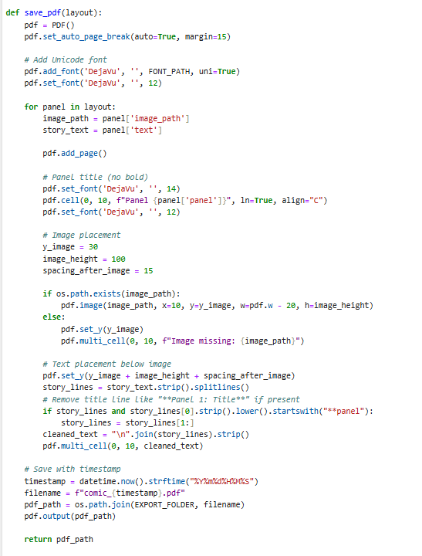

Activity 2.2: Implement the FastAPI Backend to Manage Routing and User Input Processing
Define Routes in FastAPI
All routing logic is handled in routes.py.
Each route is linked to the corresponding backend function that processes the comic generation workflow developed in Activity 2.1.
Process User Input
- HTML Form: Created in index.html
- Users enter: story prompt, main character name, setting, tone, and art style
- FastAPI captures inputs using Form(...) parameters from the request
- Pydantic schema (PromptRequest) is used to validate JSON input for API-based comic generation
Integrate Gemini API Calls
Each route handler connects directly to the respective AI-powered function modules:
- /generate →
  - Calls generate_outline() to create panel outlines from user prompt
  - Calls generate_story() to expand into narration and dialogue
  - Calls generate_image() for each panel to create comic-style images
  - Calls build_comic_layout() to organize the final layout
  - Calls save_pdf() to compile and export the complete comic into a PDF
- /generate-comic/json →
  - Similar flow as /generate, but triggered via a raw JSON API request
  - Returns JSON response with layout data and PDF path for API clients
- /test-image →
  - Calls generate_image() directly with a custom prompt to test image generation functionality separately
All AI-generated responses (text and images) are processed, cleaned, and injected into the Jinja2 frontend templates (comic_preview.html, export_success.html) for a seamless user experience.

